Chapter 18, Solution 49.

Consider the circuit shown below:
1 Ω
jω
+
v_{o}
−
j2ω
V_{S}

+
−
i₁
i₂
jω
2 Ω

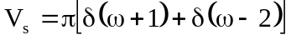

For mesh 1, 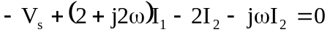
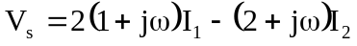 (1)

For mesh 2, 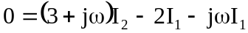
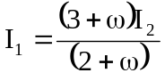 (2)

Substituting (2) into (1) gives

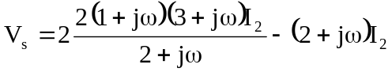
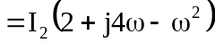
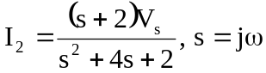

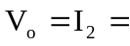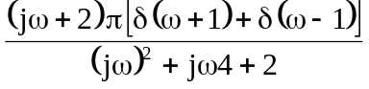
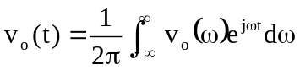
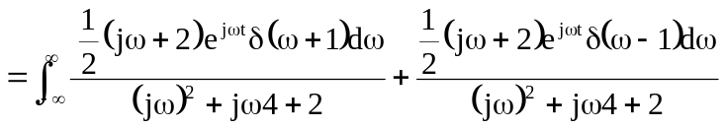
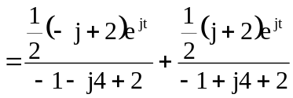
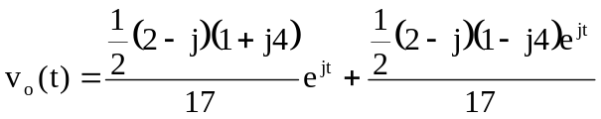
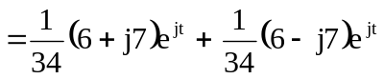
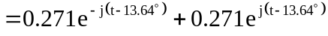

v_{o}(t) = 